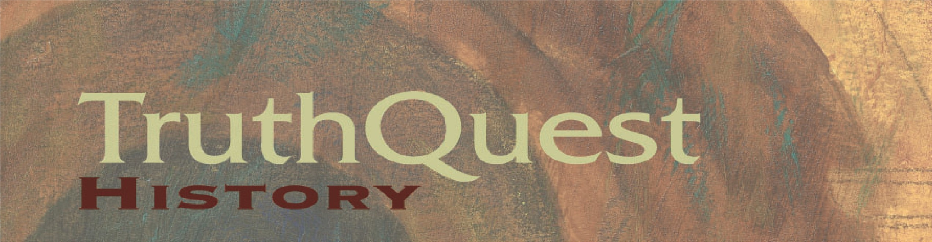
Beginnings (Creation/Old Testament/Ancients/Egypt)
________________

*Holy Bible All ages!
*Child’s Story Bible, by Catherine Vos Gr. K-2
*Story of the World: Volume I, by Susan Wise Bauer [See important note here...] Gr. 3-6
(Some families enjoy this book’s global scope, so we’ve been asked to include it as a “spine” option; others seek a different worldview. Parents, as always, the decision is yours as you let Scripture reign. We cite the 2001 edition from Peace Hill Press.)
*Genesis: A Commentary for Children, by Nancy Ganz Gr. 3-10
(And the sequels: *Exodus, *Leviticus, *Numbers, *Deuteronomy)
*Story of the Ancient World, by C. Miller & H.A. Guerber (Nothing New, 2006) Gr. 3-10
*Book of the Ancient World, by Dorothy Mills (Putnam, 1923) Gr. 6-12
*Streams of Civilization: Volume One, by Mary Stanton & Albert Hyma (1992) Gr. 9-12
*Genesis: Finding Our Roots, by Ruth Beechick Various
(Families may be able to do this together, with children of varying ages.)
*Greenleaf Guide to Old Testament History, by R. & C. Shearer (Greenleaf, 1994) Various
(Families can do this together, with children of varying ages.)

